- Purpose
  - The purpose of this document is to describe the procedure for packaging the Orbital Strip Machines.
- Scope
  - This SOP applies to all equipment assembly team members. The process applies to the following machine ID’s:
E012801EQM0600BA1000 – Basic Sand Dragon, 20”
E012801EQM0607BE1200 – Crewman ORB 20
E012801EQM0607BA1200 – Basic Sand Dragon 20, Canadian
E012801EQM0607BE1200 – Crewman ORB 20, Canadian
E012806EQM0600BA1000 – Basic Sand Dragon, 20”, w/ Weights
E012806EQM0600BE1200 – Crewman ORB 20, w/Weights
E012806EQM0607BA1200 – Basic Sand Dragon 20, w/Weights, Canadian
E012806EQM0600BE1200 – Crewman ORB 20, w/Weights, Canadian
E012811EQM0600BA1000 – Basic Sand Dragon, 28”, w/Weights
E012811EQM0600BE1000 – Crewman 28 ORB, w/Weights
E012811EQM0607BA1200 – Basic Sand Dragon 28, w/Weights, Canadian
E012811EQM0607BE1200 – Crewman ORB 28, w/Weights Canadian

- Responsibilities
  - The operations manager/supervisor is responsible for enforcing this SOP.
- Materials
  - The proper materials needed for this process are listed on the machine work order.
- Definitions

- Procedure
  - Assemble the appropriate box for the machine being packaged. For a 20” machine, use 89833 and for a 28” machine use 89834.
  - (Optional) Lay the box on its side and place the plywood ramp into it. Roll the machine into the box. Once the machine is all the way in the box, stand it up and remove the plywood.
  - Make sure that all of the accessories that are shipping with machine are in the box. This includes the manual packet.
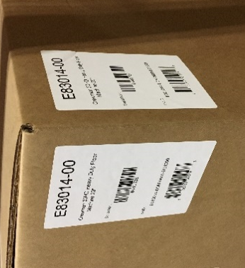
  - Place the approriate box label onto the outside of the box as shown. The label should include a barcode.
  - Tape the top of the box shut.

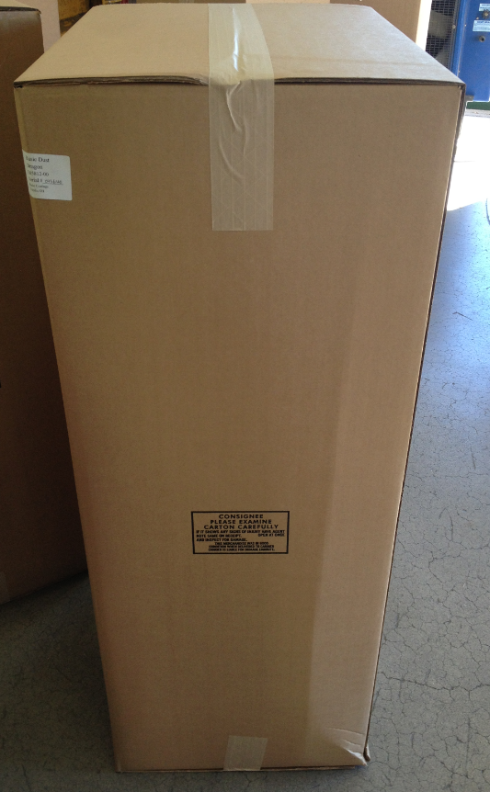

  - Put the box onto a pallet for shipment.

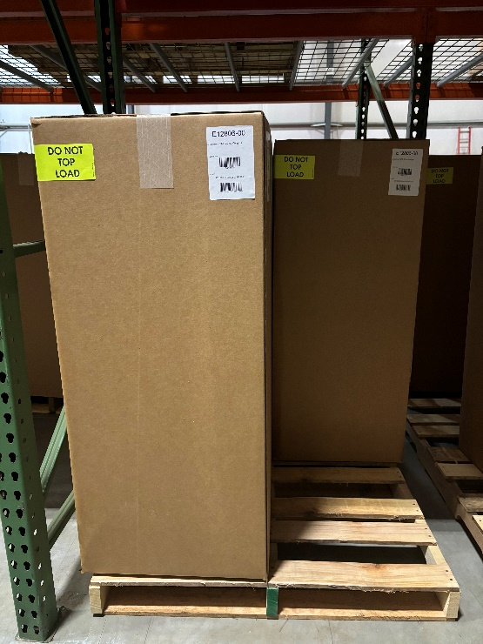

- References (optional section as needed)

- Training Guide

Functional Training Groups Requiring Training
Equipment Assembly Group

- SOP Change Control

Date of Change | Reason for Change
Rev 01 - 4/28/2015 | This is the first version of the S.O.P. hence there are no revisions to this document.
Rev 02 - 1/16/2018 | Added the Responsibilities Section
Rev 03 - 10/15/2024 | Updated Machine ID’s and add photo of box on pallet
Rev 04 - 3/6/2025 | Removed work center note

Approvals

Submitter/Author Approval:__________________________________ Date:______________________

Management Approval:______________________________________ Date:______________________

QAU Approval:_____________________________________________ Date:______________________

